Design Pattern: Factory 3

Code Snippets:

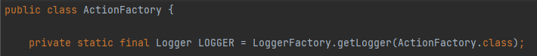

Location: src/main/java/org/jabref/gui/actions/ActionFactory.java

Explanation: This ActionFactory class is a factory method pattern because it is responsible for the creation of several instances of objects like MenuItem, CheckMenuItem, Menu, Button, etc. This way other classes(client) can use ActionFactory to create actions(objects) like the mentioned before and this process will be hidden behind the ActionFactory so the client code does not depend on concrete classes.

Design Pattern: Command

Code Snippets:

Location: src/main/java/org/jabref/cli/AuxCommandLine.java

Explanation: This AuxCommandLine class is a command pattern because it features a constructor to create a command and a execute function called perform(). This allows a sender to create a command using this class to encapsulate an order and the command can be manipulated as an object and placed into a queue so that different commands can be scheduled to be completed at different times because the command is only sent when it is executed. This command pattern is incomplete and could be improved by the addition of a unexecute/undo function in order to be able to undone or redone a command before sending it.

Design Pattern: Composite 3

Location: src/main/java/org/jabref/logic/importer/fetcher/CompositeSearchBasedFetcher.java

Explanation: This CompositeSearchBasedFetcher class is a composite designing pattern because it allows to compose objects into tree structures since the interface SearchBasedFetcher implements the default behavior which is the performSearch() method, and then the composite class defines the behavior for the children component and stores them in a set of SearchBasedFetchers called fetchers. This allows the client to treat individual objects and compositions uniformly, keeping it simple and easier to add new kinds of components. This particular composite class does not have a remove method to allow for the removal of children.

Pedro Reis, nº58751